How Euclid MER VIS disc and bar geometry are measured
Current results 20 October 2026
Adaptive Photutils pipeline with image-based centre checks
This guide explains how the disc and bar geometry are measured and shows galaxy examples. Good-looking numerical outputs remain provisional until their physical component identification is checked.

What an ellipse measurement means
An isophote is a contour of equal surface brightness. Photutils fits ellipses to these contours at successive semi-major axes, returning a centre, ellipticity, orientation, intensity, errors and convergence information. The outer-disc contours provide a projected axis ratio and disc PA; an inner stable elongated profile can provide an observed bar PA.

Preprocessing and centre validation
The code crops around the catalogue position using the segmentation-area scale r_seg=sqrt(area/pi). It retains native resolution for r_seg up to 100 pixels and uses larger bins for larger galaxies. It subtracts a sigma-clipped background, identifies the target near the centre, masks neighbouring detections and bright compact contaminants, and obtains a moment-based starting shape. Mask removal on retry is labelled.
The brightest smoothed pixel close to the catalogue position seeds the centre. Centres can move during fitting. Inner converged centres provide a new reference if the initial reference rejects too many samples. Failed cases also try catalogue and local-flux centres. A broader extended-light peak is also tested for failed cases, rather than accepting a nearby bright knot. Candidate centres still require checking for foreground-star switches and unresolved cores. Two such candidates were excluded by explicit visual-review overrides in this run. A final retry can remove a fragmented neighbour mask with mild smoothing; this is explicitly flagged because contamination may increase. The selected disc centres are then summarised by their median and scatter. Large offsets and unstable centres are flags, rather than silently accepting a bright off-centre knot as the nucleus.

What is accepted
Strict samples must have valid=True, stop code 0, at least 65% sampled coverage, ellipticity error below 0.1, PA error below 10°, positive intensity and acceptable centre displacement. Normally at least eight strict samples are sought. Disc selection uses samples brighter than the background noise; thresholds can be reduced by labelled fallbacks. Relaxed recovery permits 50% coverage, ellipticity error below 0.2, PA error below 20° and a wider centre tolerance. At least three accepted samples are required to return geometry.
Stop code 2 means the maximum iteration count was exceeded, not normal convergence. Such samples are admitted only in relaxed recovery and selected ones raise iteration_limited_samples. Stop codes 4/5 are not treated as converged geometry. An algorithm can therefore return more measurements without pretending all are equally secure.

Disc and bar selection and the angle conventions

Disc
The disc interval normally extends from max(0.5 r_out,1.25 times the selected bar end) to the outer bright radius. If it has fewer than three samples, the outermost three bright accepted samples are used and disc_range_fallback is raised. Weighted axial PA uses inverse PA-error squared, with an error floor of 0.3°. Ellipticity is the median over the selected disc interval.

Inclination
For an intrinsically circular thin disc, q=b/a=1−ellipticity and inclination i=acos(q). Thus q=1 means face on (0°), q=0.5 means 60°. This project retains q0=0. Real discs have thickness; the supplied alternative method uses q0=0.2, so its inclinations need not match even for the same measured q.

Bar
The search uses accepted isophotes from 0.5 arcsec to 0.7 r_out. A smoothed ellipticity peak must have a plateau containing at least three samples with PA scatter no more than 10°, plus an ellipticity drop or a supported change of outer PA. Candidates are ranked by quality, peak ellipticity and radius. Class A requires drop at least 0.10, scatter at most 5° and peak ellipticity at least 0.30; accepted weaker cases are B. If no candidate passes, disc geometry is retained and bar PA stays blank. A bulge, ring or arm can mimic this signature; visual confirmation remains necessary.

PA convention and mosaic orientation
Photutils pixel angles start at positive image x and turn towards positive image y. We convert directions to local celestial East and North with WCS, then compute atan2(East,North) modulo 180°. Reported PA is North towards East: 0° North–South,45° northeast–southwest,90° East–West,135° northwest–southeast. It is counterclockwise on North-up East-left images. The native mosaic grid is preserved. Across the sample, local North differs from pixel-up by median 0.141° and maximum 0.604° because of the projection.
The additional +90° is applied only to the converted Euclid catalogue comparison, not to our Photutils PA or the pixels. A different documented versus actual detection-image reference is plausible but unconfirmed. All bar angles here are observed, not deprojected.

How to interpret warnings
Sparse disc sampling: Fewer than six selected accepted disc ellipses, or a largest radial gap above half the span. PA stability is not confidently assessed; see the final explanation page.
Disc PA varies across radius: Accepted disc sky PA scatter exceeds 10°, with at least six selected accepted ellipses and no radial gap exceeding half the selected span. Nearly-face-on discs are exempt. This is a screening rule, not a calibrated confidence test.
No accepted bar; disc retained: No bar candidate passes; a disc estimate may remain useful.
Changing disc ellipticity: Selected disc ellipticity spans more than0.15.
Bar identification uncertain because of a small interval: The selected candidate interval ends below 1.5 arcsec. This may be an unresolved bar or a bulge, spiral arm or noise feature. It does not establish the presence of a bar.
Disc interval fallback: The normal disc interval had fewer than three samples.
Bar and disc intervals close: Disc samples approach or overlap the selected bar interval.
Small disc: Bright outer radius is below 2 arcsec.
Weaker accepted bar signature: An accepted class B candidate meets the broader bar-profile test but misses one or more class A thresholds. See the class A and B explanation at the end of this document.
Large centre offset: Median selected-disc centre is farther from the catalogue position than the operational threshold.
Relaxed recovery: Recovery used broader acceptance criteria; inspect the result.
Iteration-limited samples: At least one selected sample reached the iteration limit.
Star mask removed in retry: A retry without the compact-star mask was used.
Neighbour mask removed in recovery: Fragmented target segmentation prompted a retry without the neighbour mask; inspect contamination carefully.
Centre changes across disc: Selected-disc centres vary beyond the operational threshold.
Short accepted profile: Fewer than ten accepted isophotes in the returned profile.
High inclination: The inferred inclination is at least 80°.
Nearly face-on is information, not a defect: 59 fitted discs have q>0.90. PA is intrinsically uncertain for a circle, while deprojection is small. The manifest separates codex_information from counted quality flags. QI also includes failed fits and partial requested coverage, which does not necessarily mean the galaxy itself is truncated.

An example of checking the galaxy centre
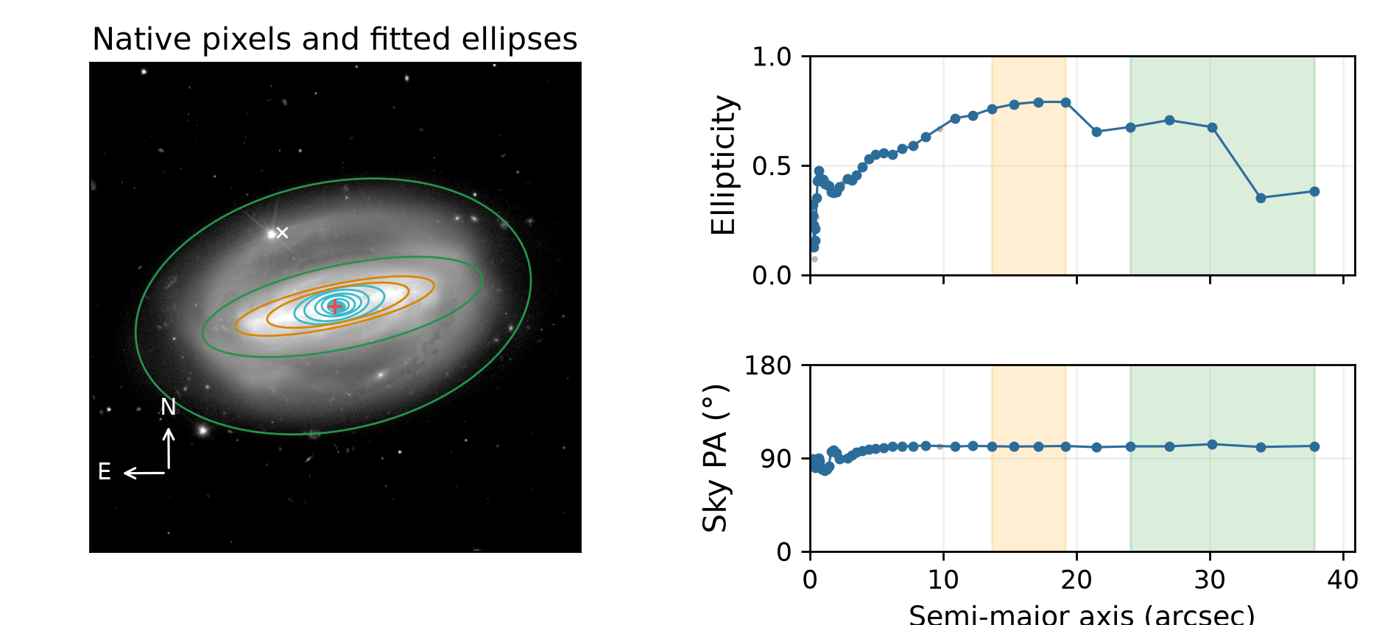
Galaxy 2700376345666189458. Disc PA 101.52°; bar PA 101.48°; inclination 71.05°. Method: recentred. Accepted ellipses: 43. Flags: Large centre offset, Changing disc ellipticity. Centre offset: 17.320 arcsec.
The white catalogue marker lies away from the bright central galaxy light; the fitted ellipse centre is the red marker. This demonstrates why the catalogue position must be checked. The large centre offset remains a review flag even when the fitted centre looks plausible. The original image and catalogue position are preserved, and this example is not presented as a single-flag case.

Example 1 with no counted geometry issues
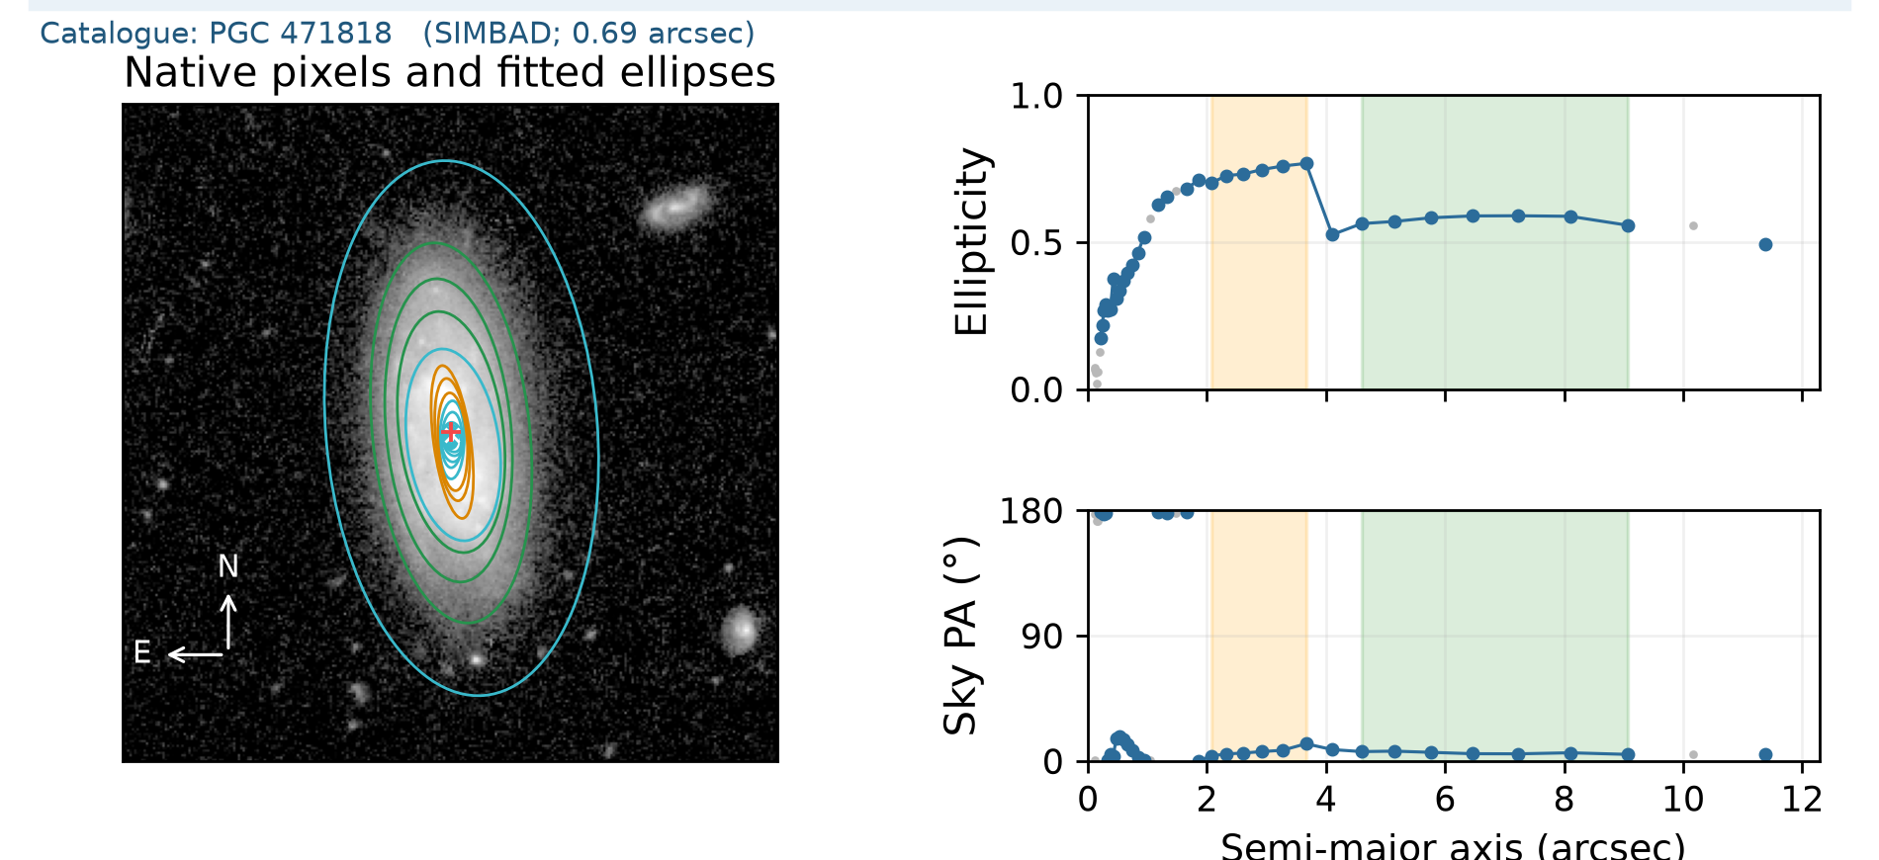
Galaxy -623118358499243253. Disc PA 5.91°; bar PA 7.05°; inclination 65.36°. Accepted disc ellipses: 7. Flags: none. Centre offset 0.128 arcsec.
Green marks the selected disc interval; orange marks the accepted bar. Look for stable outer PA, a modest ellipticity variation and a stable inner bar direction. A NoQI label screens the numerical conditions but does not independently validate the physical component identification.

Example 2 with no counted geometry issues
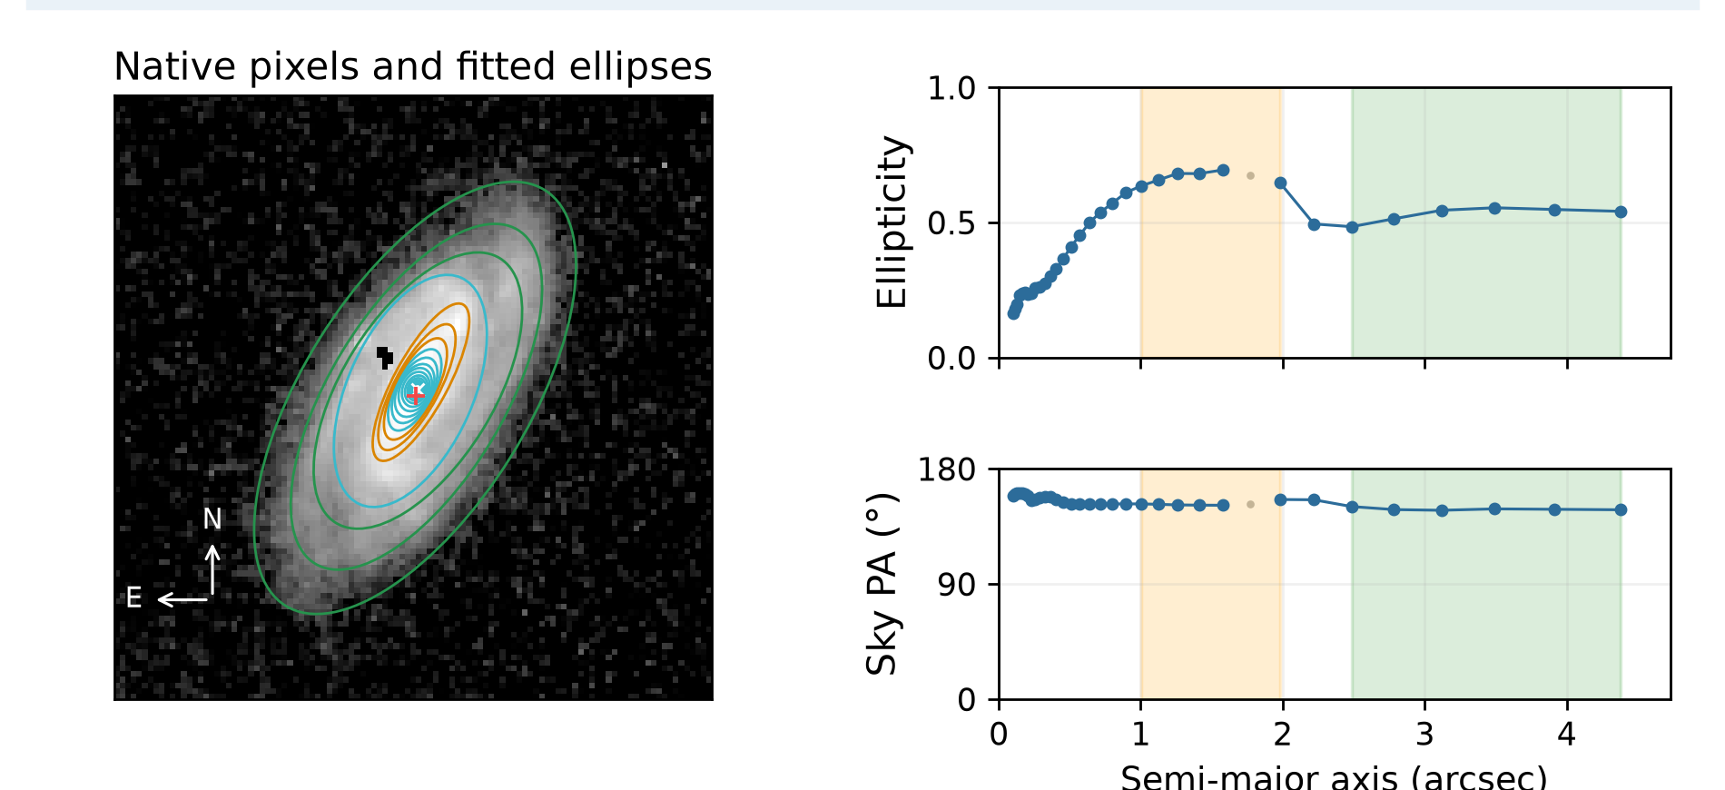
Galaxy -527683439283031054. Disc PA 148.42°; bar PA 152.60°; inclination 62.82°. Accepted disc ellipses: 6. Flags: none. Centre offset 0.107 arcsec.
Green marks the selected disc interval; orange marks the accepted bar. Look for stable outer PA, a modest ellipticity variation and a stable inner bar direction. A NoQI label screens the numerical conditions but does not independently validate the physical component identification.

Example 3 with no counted geometry issues
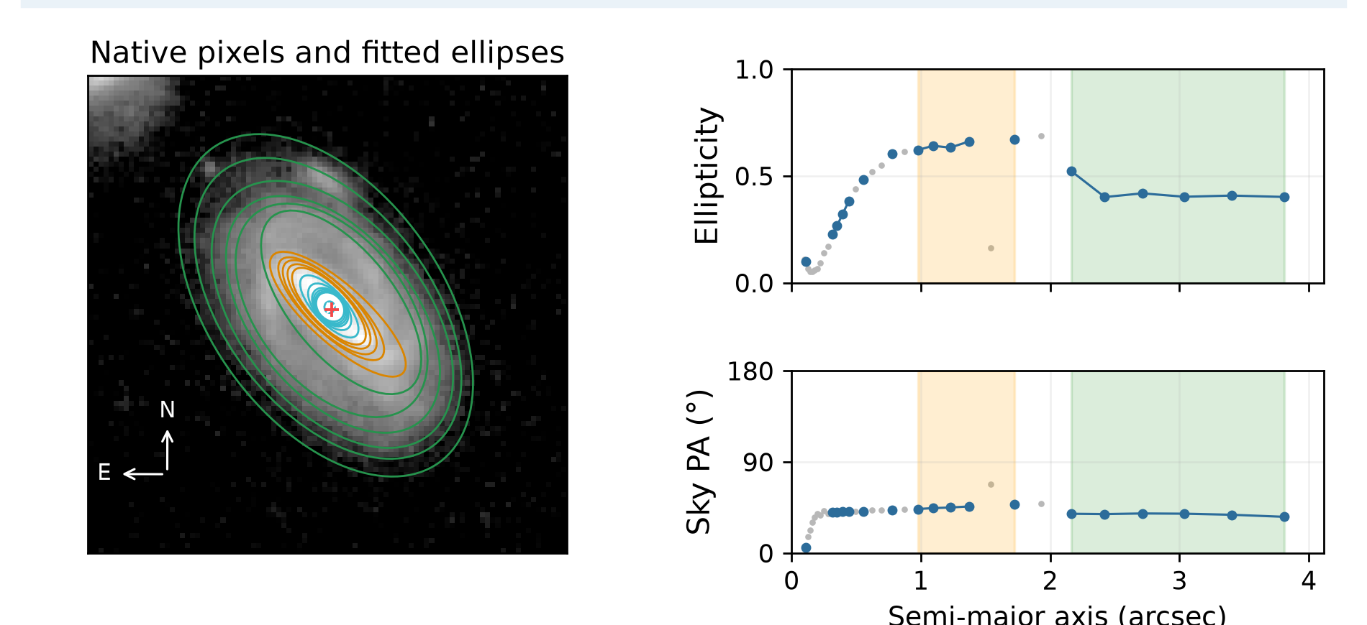
Galaxy -639567775462084647. Disc PA 38.60°; bar PA 46.34°; inclination 53.54°. Accepted disc ellipses: 6. Flags: none. Centre offset 0.032 arcsec.
Green marks the selected disc interval; orange marks the accepted bar. Look for stable outer PA, a modest ellipticity variation and a stable inner bar direction. A NoQI label screens the numerical conditions but does not independently validate the physical component identification.

Example 4 with no counted geometry issues
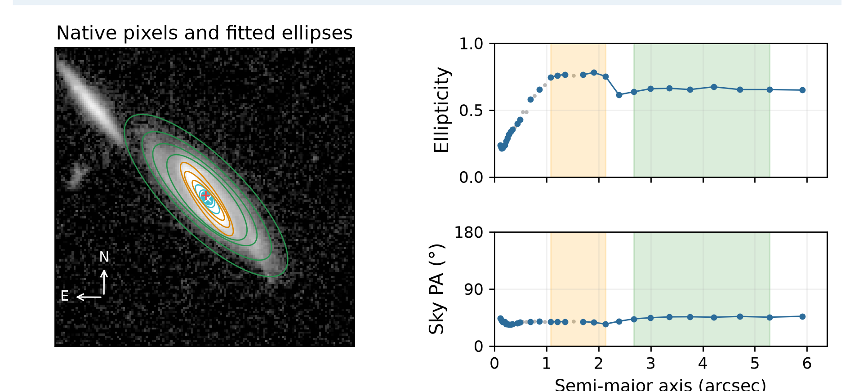
Galaxy 2652188688676008031. Disc PA 45.55°; bar PA 36.53°; inclination 69.76°. Accepted disc ellipses: 7. Flags: none. Centre offset 0.171 arcsec.
Green marks the selected disc interval; orange marks the accepted bar. Look for stable outer PA, a modest ellipticity variation and a stable inner bar direction. A NoQI label screens the numerical conditions but does not independently validate the physical component identification.

Example 1 requiring disc orientation review
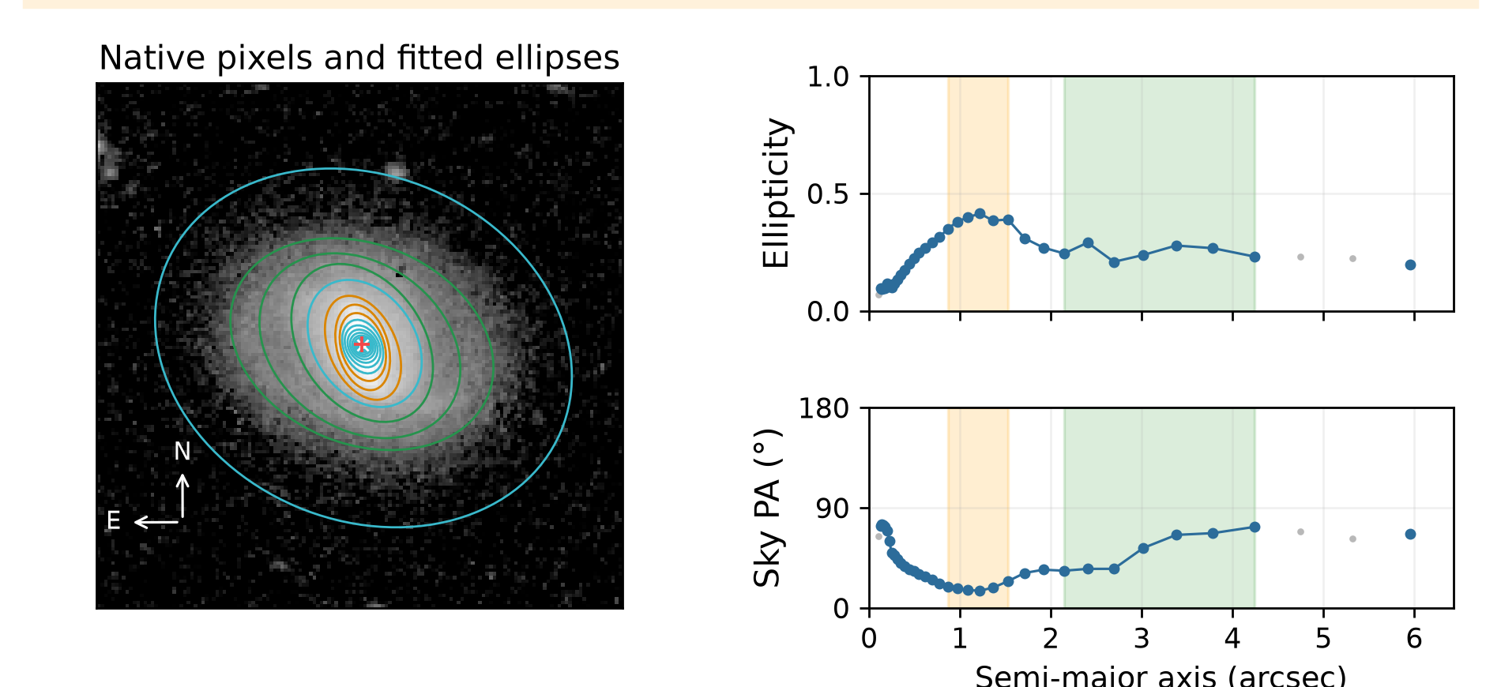
Galaxy -601121275504424227. Disc PA 60.75°; bar PA 20.23°; inclination 40.93°. Accepted disc ellipses: 7. Flags: Disc PA varies across radius. Centre offset 0.039 arcsec.
Disc PA scatter is 15.88°. The well-sampled accepted outer contours change direction. Inspect the image and profile to distinguish a systematic twist from scatter, spiral structure, contamination or centre movement.

Example 2 requiring disc orientation review
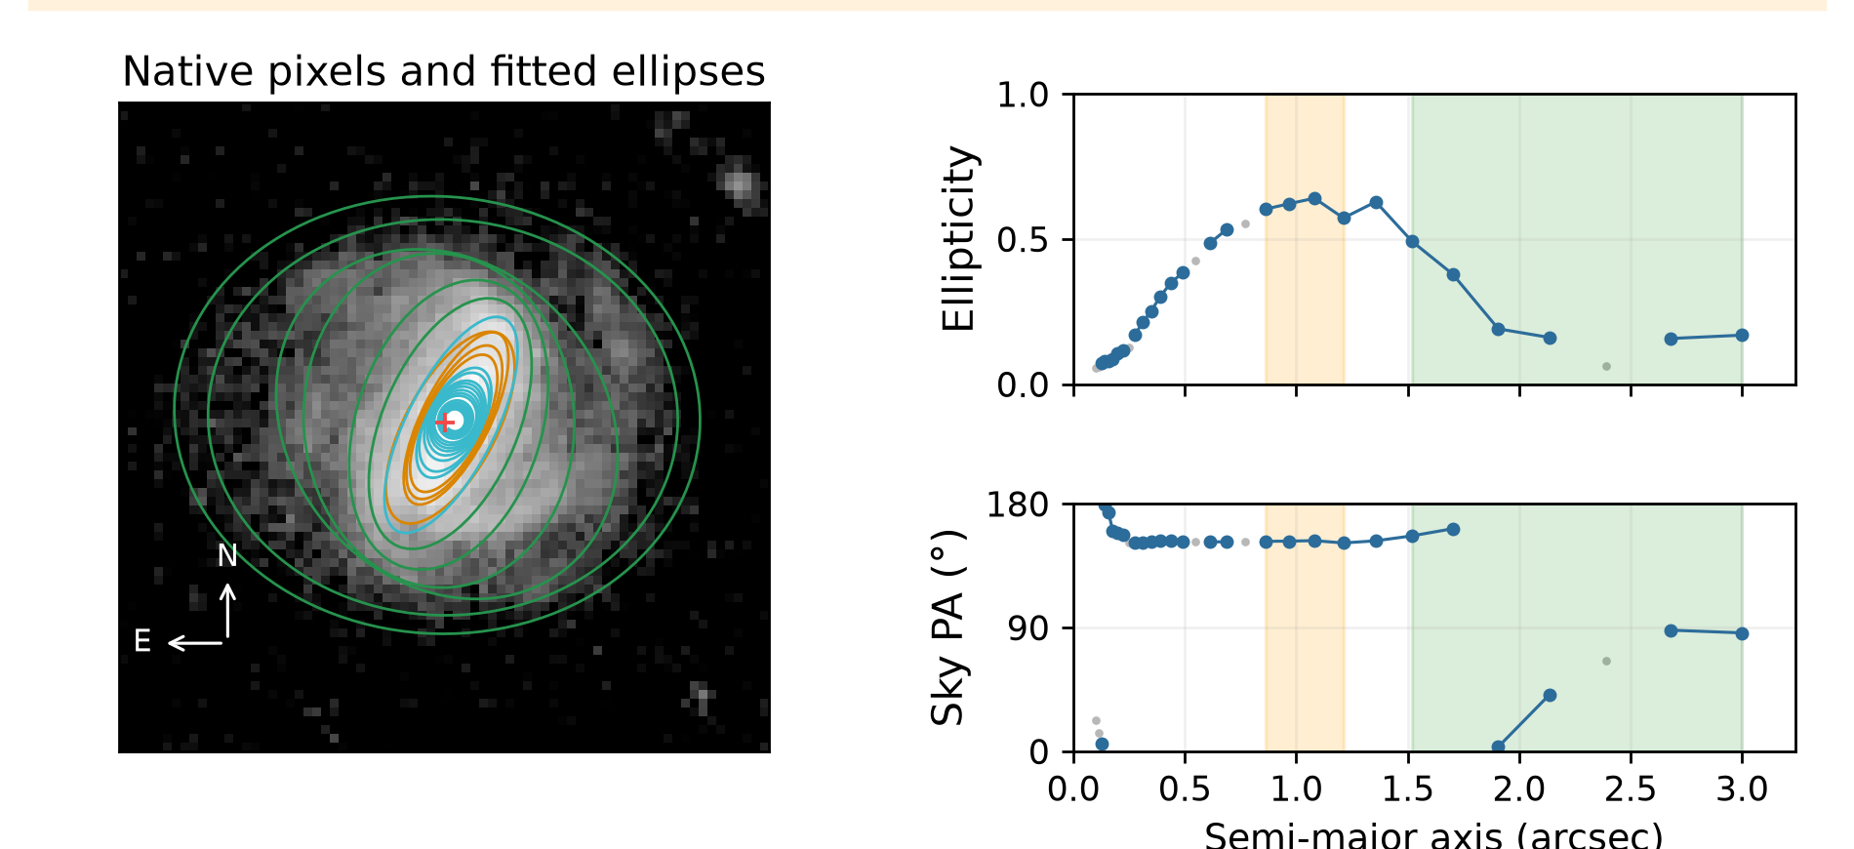
Galaxy 2708530616682862270. Disc PA 159.87°; bar PA 152.61°; inclination 34.91°. Accepted disc ellipses: 6. Flags: Changing disc ellipticity, Bar identification uncertain: small interval, Disc PA varies across radius. Centre offset 0.074 arcsec.
Disc PA scatter is 54.75°. The well-sampled accepted outer contours change direction. Inspect the image and profile to distinguish a systematic twist from scatter, spiral structure, contamination or centre movement.

Reproducibility and limits
The current run records the algorithm and catalogue hashes, method, masks, binning, centres, accepted sample counts and flags. Original science FITS files are untouched. Quality thresholds and the known-geometry synthetic test are operational checks, not an independent calibration of scientific accuracy.

Understanding the bar signature classes

What class A and class B mean
These are operational categories defined by our ellipse-fitting code. They describe how clearly the radial ellipse profiles resemble a bar. They are not Galaxy Zoo or Zoobot classes, probabilities of a bar, or measurements of physical bar strength.

The common acceptance test
A candidate must have a smoothed ellipticity peak of at least 0.20 and a plateau of at least three accepted ellipses. The plateau sky PA scatter must be no more than 10°. Beyond the peak, ellipticity must drop by at least 0.08; alternatively, a drop of at least 0.04 is accepted if the outer PA twist or difference from the preliminary outer-disc PA is at least 10°.

Class A means a clearer ellipse signature
An accepted candidate is class A only if all three stronger conditions hold: ellipticity drops by at least 0.10 beyond the peak; plateau PA scatter is no more than 5°; and peak ellipticity is at least 0.30. Ellipticity is 1 − b/a, so 0.30 corresponds to an ellipse axis ratio b/a of 0.70.

Class B means accepted with weaker evidence
A candidate is class B if it passes the common acceptance test but misses at least one class A threshold. For example, peak ellipticity 0.35, drop 0.08 and PA scatter 4° passes the common test but is B because the drop is below 0.10. Peak ellipticity 0.40, drop 0.15 and scatter 7° is also B because scatter exceeds 5°.

How to interpret the quality flag
The flag weak_ellipse_bar_signature marks every accepted class B candidate for review. Class B does not mean that the galaxy definitely has a physically weak bar. A bulge, ring or spiral arm can mimic a bar profile, including a class A profile. Inspect the image and selected ellipses before adopting the bar PA. If no candidate passes the common test, no bar PA is adopted; the disc measurement may still be retained.

Reading the profiles and assessing disc sampling

Accepted and rejected points
Blue points are accepted ellipse measurements. Grey points fail one or more acceptance checks and are excluded from the adopted disc PA and its scatter. Green shading identifies the selected radial interval; it does not mean that all points inside it are accepted. Lines connect accepted points only and now break across rejected samples. They are visual guides, not fitted curves.

Sparse sampling is distinct from PA variation
For non-face-on discs, the PA variation screen requires at least six selected accepted ellipses and no radial gap greater than half the selected span. Otherwise sparse disc sampling is flagged, while numerical PA and scatter remain in the manifest. With adequate sampling, scatter above 10° raises the radial PA variation flag. Nearly-face-on discs are exempt from both PA flags. These operational thresholds require validation; neighbouring ellipses are correlated and the count is not a number of independent observations.

Examples discussed during review
Galaxy -518633776290631360 has three selected accepted disc ellipses in the stored interval and a largest gap of about 78% of its span. A point beside the green boundary can appear to be a fourth; selection uses the stored radii. Its label is now sparse disc sampling. Galaxy -601121275504424227 has seven selected accepted disc ellipses and a largest gap of about 22%; its sustained PA change is retained as radial PA variation.

Bar candidates and failed fit displays
Galaxy Zoo and Zoobot identify bar candidates. A small selected bar interval can be a real unresolved bar or a different feature. Class A/B describes the ellipse-profile evidence, not physical bar strength or confirmation. Failed fits have no adopted centre, PA or inclination. Their report images now omit fallback centre markers and rejected ellipse overlays, which previously looked misleadingly like adopted geometry. Raw FITS pixels are unchanged.

Established catalogue identifiers
A coordinate cross-match against SIMBAD and VizieR HyperLEDA VII/237 found 227 secure positional identifications: 224 through SIMBAD and three additional VizieR matches. These have one galaxy identity within 5 arcsec and an adopted separation no greater than 2 arcsec from the Euclid catalogue coordinates. Their identifiers and match separations appear on the PNGs. No Messier, NGC or IC identifier was returned among the accepted matches. One ambiguous case and 13 candidates outside the secure radius remain unassigned. A non-match means no secure identity in these searches, not absence from all catalogues. The manifest records source, separation, link and query date; the full candidate results are retained.

